Bedwas Gymnastics Club

**Adverse Weather & Event Policy**

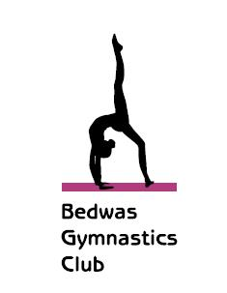

January 2018

**Policy Review Record**

The Company Policy for Adverse Weather was first issued in this format:

|  |  |  |
| --- | --- | --- |
| Revision No. | Date | Details |
| **1** | **January 2018** | **New Bespoke Policy Prepared** |

Page 1 of 3

# 

**Contents**

1. Policy Aim
2. Procedure
3. Notification
4. Fees
5. Opening

Page 2 of 3

1. **Policy aim**

It is the aim to remain open except in the most extreme circumstances where it has become impossible to deliver gymnastics sessions.

2. **Procedure**

2.1 In the event of extreme weather conditions, the situation will be assessed at regular intervals throughout the day at 9am, 11am and 2pm.

2.2 In the case of an adverse event, the situation will be assessed as soon as practically possible following notification of the event occurring.

3. **Notification**

3.1 In the event that the decision is made to close this will be communicated via the website and social media no later than 9am for daytime classes and 3pm for evening classes.

3.2 In the event that the decision is made to close during an ongoing class this will be communicated via phone calls home, the website and social media.

4. **Fees**

In the event that the club has to close due to circumstances beyond our control no refund/credit will be offered.

5. **Opening**

In the event of closure due to adverse weather the situation will be reassessed on a day to day basis and the outcome will be communicated via the website and social media at the times stated in 3.1.

Page 3 of 3